**W7MSRF657**

**Francois Cloete**

**C# Basic Project 1**

**Blackjack**

**MLBC175-01**

**Program Design**

Name: Blackjack

Goal: create a program using windows forms to emulate a game of blackjack between a human player and an AI dealer.

Features:

* Able to bet virtual currency from an auto-generated bankroll. Maximum bet of 500, can bet more than in the bankroll.
* Button to deal a hand of 2 cards to both the player and dealer. One of the dealers cards are facedown.
* Button to quit the program.
* Scoreboard showing the amount of wins, losses and ties. (Determined by whether money was won or lost in a round).
* Message to display how much has been won or lost and the result.
* NumericUpDown to set how many packs of cards to use for the game (maximum of 5).
* NumericUpDown to set how much a blackjack hand (2 cards equalling a value of 21) pays out (multiplication) (maximum of 2.50).
* Checkbox to allow unnatural splits (mostly for use of testing the splitting function) (allows any 2 cards to be split not just cards of the same rank).
* One hand for the dealer and 4 hand spaces for the player in case of splits.
* Button to hit the current player hand (draws a card from the deck to the hand).
* Button to stand (disable the hand, switch to the next active player hand. If there are no other player hands the dealer plays and the result is calculated).
* Player auto-stands on a hand value of 21
* Button to split the current 2 card hand (moves one card to another hand if one is available, draws a card for both of these hands. (is disabled if there are no empty hand spaces left).
* Button to double (doubles the bet amount of the active hand, draws a card and then stands).
* Text display for each hand (players and dealer) to display messages in case of blackjack or bust. In case of the player it also displays the value of the hand.
* 2 methods of shuffling cards, only one method is implemented for the blackjack program.
* Cards program has multiple card backs
* All image assets are compressed into one .net managed resource.
* Cards program is built independently so that it can be reused for any other card game that uses a standard deck of cards. Comments are written in respect to the blackjack game for the purposes of this project.
* No try/catch block is used, only appropriate place for a try/catch block would be for the image resources, but as they are in a .net managed resource file the program won’t compile without it. Thus the try/catch block’s code wouldn’t even be reached.
* Current active hand is highlighted to avoid confusion for the player when splitting, the highlight box covers both the hand and the message for the hand.

**Source Code:**

/*

* File Name: Program.cs

* Author: Francois Cloete W7MSRF657

* Date Created: 22 May 2017

* Operating System: Windows 7 64-bit

* Version Number: 1.0

* Description: Main entry point for the application

*/

using System;

using System.Collections.Generic;

using System.Windows.Forms;

namespace Blackjack

{

static class Program

{

[STAThread]

static void Main()

{

Application.EnableVisualStyles();

Application.SetCompatibleTextRenderingDefault(false);

Application.Run(new FormGame());

}

}

}

/*

* File Name: BlackjackHand.cs

* Author: Francois Cloete W7MSRF657

* Date Created: 22 May 2017

* Operating System: Windows 7 64-bit

* Version Number: 1.3

* Description: Contains the minimum functionality and required features of a blackjack hand,

* either for the player or the dealer.

*/

using System;

using System.Collections.Generic;

using System.Drawing;

using System.Text;

//using the cards program (used for deck creation and management)

using Cards;

namespace Blackjack //part of the Blackjack namespace

{

//defines the BlackjackHand class as abstract and inherits from the PileOfCards class

//from the Cards namespace

public abstract class BlackjackHand : PileOfCards

{

//declares the event named change which is triggered everytime a hand of cards is altered

public event EventHandler Changed;

//constructor for the BlackjackHand class, used as reference for the inheriting class

public BlackjackHand(params Card[] cards)

: base(cards)

{

}

// Expose all cards in this hand. Used to reveal any cards that are face down.

public void Expose()

{

foreach (Card c in cards) c.FaceUp = true;

FireChangedEvent(); //calls method to trigger the changed event.

}

// Add a card to the hand.

public virtual void Hit(Card c)

{

cards.Add(c);

FireChangedEvent(); //calls method to trigger the changed event.

}

// Get value (closest to 21 that can be made).

public int Value

{

get

{

int value = 0, aces = 0;

foreach (Card c in this)

{

if (c.Rank == Ranks.Ace)

{

value += 1;

aces++;

}

else if (c.Rank < Ranks.Ten)

value += (int)c.Rank;

else

value += 10;

}

while (value <= 11 && aces > 0)

{

// Count one ace high instead of low:

value += 10;

aces--;

}

return value;

}

}

// Get the smallest possible value (aces count as 1s)

public int MinValue

{

get

{

int value = 0;

foreach (Card c in this)

{

if (c.Rank < Ranks.Ten)

value += (int)c.Rank;

else

value += 10;

}

return value;

}

}

// Returns true if at least one ace can be counted "high".

public bool IsSoft

{

get

{

return MinValue != Value;

}

}

// Returns true if the hand is bust.

public bool IsBusted

{

get

{

return (Value > 21);

}

}

// Returns true if the hand is a blackjack.

public bool IsBlackjack

{

get

{

return (Count == 2 && Value == 21);

}

}

// Returns the hand as a string of card names.

public override string ToString()

{

string results = "";

foreach (Card c in cards)

{

results += c.ToString() + " ";

}

return results;

}

protected void FireChangedEvent()

{

if (Changed != null) Changed(this, EventArgs.Empty);

}

}

}

/*

* File Name: BlackjackHandPanel.cs

* Author: Francois Cloete W7MSRF657

* Date Created: 22 May 2017

* Operating System: Windows 7 64-bit

* Version Number: 1.6

* Description: Contains functionality to display the hand, message and value of the hand

* in an object which can be altered procedurally

*/

using System;

using System.Collections.Generic;

using System.ComponentModel;

using System.Drawing;

using System.Data;

using System.Text;

using System.Windows.Forms;

//using the cards program (used for deck creation and management).

using Cards;

namespace Blackjack //part of the Blackjack namespace.

{

//inherits from the card panel class.

public partial class BlackjackHandPanel : CardPanel

{

//used to initialise the component.

public BlackjackHandPanel()

{

InitializeComponent();

}

[Browsable(false)] //removes this property from the properties window.

//get and set methods for BlackjackHand. sets the changed event handler and calls the refresh method

public BlackjackHand Hand {

get

{

return (Cards as BlackjackHand);

}

set

{

if (Cards != null && Cards is BlackjackHand) (Cards as BlackjackHand).Changed -= hand_Changed;

Cards = value;

if (Cards != null) (Cards as BlackjackHand).Changed += hand_Changed;

Refresh();

}

}

//hand changed event handler. calls the refresh method.

void hand_Changed(object sender, EventArgs e) {

Refresh();

}

//override of refresh method, calls the update status method.

public override void Refresh() {

this.Invalidate();

UpdateStatus();

}

//update status method, changes message and message colour based on the hand.

//displays player hand value.

private void UpdateStatus() {

//checks if hand is null (no game started, hand is empty)

if (Hand != null)

{

//checks if current hand has blackjack (2 cards that have a value of 21)

if (Hand.IsBlackjack) {

//changes message colour to blue and displays message.

ForeColor = Color.Blue;

Text = "Blackjack!";

}

//checks if current hand is bust.

else if (Hand.IsBusted) {

//changes message colour and displays message.

ForeColor = Color.Yellow;

Text = "Bust!";

}

//if hand is not bust or blackjack this code block is run.

else

{

int value = 0; //local storage variable for hand value

value = this.Hand.Value; //setting value to be equal to the value of this hand. (calls method to check).

//if it is the players hand thent he value is displayed

if (this.Hand is PlayerBlackjackHand)

{

ForeColor = Color.Yellow;

Text = value.ToString();

}

//if it is not player hand then it must be the dealers hand.

//since one card is facedown no value is displayed.

else

{

ForeColor = Color.Yellow;

Text = "";

}

}

}

//if hand is null set message to be blank.

else {

Text = "";

}

}

}

}

/*

* File Name: DealerBlackjackHand.cs

* Author: Francois Cloete W7MSRF657

* Date Created: 22 May 2017

* Operating System: Windows 7 64-bit

* Version Number: 1.1

* Description: Dealer's blackjack hand. The basic BlackjackHand functionality is enhanced with

* aspects specific to the dealer.

*/

using System;

using System.Collections.Generic;

using System.Text;

//uses the cards program

using Cards;

namespace Blackjack //part of the blackjack namespace

{

//inherits from BlackjackHand

public class DealerBlackjackHand : BlackjackHand

{

//constructor for DealerBlackjackHand

public DealerBlackjackHand(params Card[] _cards)

: base(_cards)

{

}

//method to determine if the dealer draws as the dealer must draw until they have a value above 17.

public bool DealerDraws

{

get

{

return (Value < 17);

}

}

//overide of hit method from BlackjackHand class as the dealer has

//to hit until they are above 17 and cant hit after passing 17.

public override void Hit(Card c)

{

if (!DealerDraws)

{

throw new Exception("Dealer is drawing with too high a hand value!");

}

base.Hit(c);

}

// Returns the amount won or lost based on the dealer's

// hand. Returns 0.0M for "push" (tie).

// This method is called for each player hand in the case of splits.

//and is doubled on the calling procedures side if the double button was used.

public decimal BetResult(PlayerBlackjackHand playerHand, decimal blackjackPayout)

{

if (this.IsBlackjack && playerHand.IsBlackjack)

{

return 0.0M;

}

if (this.IsBlackjack)

{

return -playerHand.Bet;

}

if (playerHand.IsBlackjack)

{

return playerHand.Bet * blackjackPayout;

}

if (playerHand.IsBusted)

{

return -playerHand.Bet;

}

if (this.IsBusted)

{

return playerHand.Bet;

}

if (this.Value == playerHand.Value)

{

return 0.0M;

}

if (this.Value < playerHand.Value)

{

return playerHand.Bet;

}

return -playerHand.Bet;

}

}

}

/*

* File Name: FormGame.cs

* Author: Francois Cloete W7MSRF657

* Date Created: 22 May 2017

* Operating System: Windows 7 64-bit

* Version Number: 4.7

* Description: Contains the base program code for the game of blackjack as

* well as all button events and variables from that.

* This is the main code for the game and most methods are called from here

* or called by the methods that were called here.

*/

using System;

using System.Collections.Generic;

using System.ComponentModel;

using System.Data;

using System.Drawing;

using System.Text;

using System.Windows.Forms;

//uses the cards program namespace.

using Cards;

using System.Diagnostics;

using System.Media;

namespace Blackjack //part of the blackjack namespace

{

//standard generation of the form class

public partial class FormGame : Form

{

//setting the amount of starting cash the player has.

//Uses the default currency of the language and timezone settings that windows uses.

private decimal bankroll = 1000.0M;

//variable to store the amount of wins

private int wins = 0;

//variable to store the amount of ties

private int ties = 0;

//variable to store the amount of losses

private int losses = 0;

//declares a null deck of cards

private Deck deck = null;

//declares a dealer hand

private DealerBlackjackHand dealerHand = null;

//declares an array of hand panels for the player

private BlackjackHandPanel[] playerPanels = null;

//declares an array list of player hands

private List<PlayerBlackjackHand> playerHands;

//variable for the index of the current hand in play. (used for splitting)

private int handInPlay;

//declares soundtrack variable (unimplemented due to not having a file for it)

//private SoundPlayer gameSound;

//initialises the form sets default colour for config boxes,

//populates array list for panels, initialises hand index and creates player hands

public FormGame()

{

InitializeComponent();

bankGroupBox.BackColor = configurationGroupBox.BackColor = Color.FromArgb(128, bankGroupBox.BackColor);

playerHands = new List<PlayerBlackjackHand>();

playerPanels = new[] { playerHandPanel1, playerHandPanel2, playerHandPanel3, playerHandPanel4 };

handInPlay = 0;

//! add game sound later!

// gameSound = new SoundPlayer(@"..\..\Resources\soundtrack.wav");

// gameSound.Play();

}

//starts the game

private void FormGameLoad(object sender, EventArgs e)

{

// Start game:

resultsLabel.Text = "";

StartGame();

}

//enables the config boxes and displays the bankroll

private void StartGame()

{

configurationGroupBox.Enabled = true;

bankGroupBox.Enabled = true;

bankrollTextBox.Text = bankroll.ToString("c0");

}

//deals cards

private void DealButtonClick(object sender, EventArgs e)

{

//checks if unnatural splits is enabled

PlayerBlackjackHand.AllowUnnaturalSplits = allowUnnaturalSplitsCheckBox.Checked;

//creates a new blackjack shoe containing the number of decks specified.

deck = new Shoe((int)deckNumericUpDown.Value);

//calls method to shuffle the deck

deck.PerfectShuffle();

//declares dealer Hand

dealerHand = new DealerBlackjackHand();

//declares player hands

playerHands = new List<PlayerBlackjackHand>();

//declares player hand sending the bet amount to the constructor for storage.

PlayerBlackjackHand hand = new PlayerBlackjackHand(betAmountNumericUpDown.Value);

//adds the hand to the player hand

playerHands.Add(hand);

//ensures that the hand index is set to 0

handInPlay = 0;

//populates the staring hands of both player and dealer,

//first card dealt to dealer is facedown (reason for false parameter).

hand.Hit(deck.Deal(true));

dealerHand.Hit(deck.Deal(false));

hand.Hit(deck.Deal(true));

dealerHand.Hit(deck.Deal(true));

// Shut down the dealing area for now,

// until end of hand.

bankGroupBox.Enabled = false;

configurationGroupBox.Enabled = false;

resultsLabel.Text = "";

// Show hands.

dealerHandPanel.Hand = dealerHand;

SetPlayerHands();

// Configure controls for the current hand:

if (playerHands[handInPlay].IsBlackjack)

{

standButton.Enabled = true;

standButton.PerformClick();

}

else

{

// Check for dealer blackjack

if (dealerHand.IsBlackjack) handInPlay = 1;

ConfigureControls(handInPlay);

}

}

private void ConfigureControls(int handNum)

{

// If handNum > all player hands then it's the dealer's turn

if (handNum < playerHands.Count)

{

PlayerBlackjackHand hand = playerHands[handNum];

hitButton.Enabled = (!hand.IsStood && !hand.IsBusted && !hand.IsBlackjack);

standButton.Enabled = true;

splitButton.Enabled = (hand.IsSplittable && playerHands.Count < 4);

doubleButton.Enabled = hand.IsDoubleable;

}

else

{

// Disable the player controls

hitButton.Enabled = standButton.Enabled = splitButton.Enabled = doubleButton.Enabled = false;

// Expose dealer's hand

dealerHand.Expose();

// Dealer's turn

bool dealerMustPlay = false;

//checks if dealer must play by checking if all player hands have blackjack or have gone bust.

foreach (PlayerBlackjackHand playerHand in playerHands)

{

if (!playerHand.IsBusted && !playerHand.IsBlackjack)

{

dealerMustPlay = true;

break;

}

}

//dealer hits and gets faceup cards until his value is greater than 17

if (dealerMustPlay)

{

while (dealerHand.DealerDraws)

{

dealerHand.Hit(deck.Deal(true));

}

}

// Calculate the results of the bet and

// reset for the next deal

decimal betResult = 0.0M;

foreach (PlayerBlackjackHand hand in playerHands)

{

betResult += dealerHand.BetResult(hand,

blackjackPayoutNumericUpDown.Value);

}

if (betResult == 0)

{

resultsLabel.Text = "You broke even";

ties += 1;

lblTies.Text = "Ties: " + ties;

}

else if (betResult < 0)

{

resultsLabel.Text = "You lost " + (-betResult).ToString("c0") + " (ha ha)!";

losses += 1;

lblLosses.Text = "Losses: " + losses;

}

else

{

resultsLabel.Text = "You won " + betResult.ToString("c0");

wins += 1;

lblWins.Text = "Wins: " + wins;

}

bankroll += betResult;

StartGame();

}

//Highlight hand in play, (useful for splitting to see which hand is active)

for (int i = 0; i < 4; i++)

{

playerPanels[i].Highlight = (i == handNum && handNum < playerHands.Count);

}

}

//checks each player panels hand to see if it has cards,

//if true, the hand is added to the panel, if false the panel hand is set to null.

private void SetPlayerHands()

{

for (int i = 0; i < 4; i++)

{

playerPanels[i].Hand = (i < playerHands.Count ? playerHands[i] : null);

}

}

//draws a card for the active hand and calls setPlayerHands method to updated the GUI

//then checks if hand is blackjack, 21 0r bust and stands if true, else controls for play are enabled for that hand.

private void HitButtonClick(object sender, EventArgs e)

{

playerHands[handInPlay].Hit(deck.Deal(true));

SetPlayerHands();

if (playerHands[handInPlay].IsBlackjack || playerHands[handInPlay].IsBusted || playerHands[handInPlay].Value == 21)

{

standButton.PerformClick();

}

else

{

ConfigureControls(handInPlay);

}

}

//sets current hand to stand. increases the index for hand in play, sets player hands and configures controls

//(disables or enables controls depending on whether there is still an active hand.

private void StandButtonClick(object sender, EventArgs e)

{

playerHands[handInPlay].Stand();

handInPlay++;

SetPlayerHands();

ConfigureControls(handInPlay);

}

//splits the hand by moving one card to another player hand and draws a new card for each hand

//then checks if the active hand has a value of 21 and stands if it does.

//else it configures controls (which checks for bust ect.)

private void SplitButtonClick(object sender, EventArgs e)

{

PlayerBlackjackHand newHand = playerHands[handInPlay].Split(deck.Deal(true), deck.Deal(true));

playerHands.Add(newHand);

SetPlayerHands();

if (playerHands[handInPlay].Value == 21)

{

standButton.PerformClick();

}

else

{

ConfigureControls(handInPlay);

}

}

//sets hand to double and hits. play cannot continue for the current hand after doubling.

//increments hand index, sets hands and configures controls.

private void DoubleButtonClick(object sender, EventArgs e)

{

playerHands[handInPlay].Double(deck.Deal(true));

handInPlay++;

SetPlayerHands();

ConfigureControls(handInPlay);

}

//closes application

private void btnExit_Click(object sender, EventArgs e)

{

this.Close();

}

}

}

/*

* File Name: PlayerBlackjackHand.cs

* Author: Francois Cloete W7MSRF657

* Date Created: 22 May 2017

* Operating System: Windows 7 64-bit

* Version Number: 3.2

* Description: Player's blackjack hand. The basic BlackjackHand functionality is

enhanced with player-specific features. Because of splits, there may

be several player hands at any given time.

*/

using System;

using System.Collections.Generic;

using System.Text;

//using the cards namespace

using Cards;

namespace Blackjack //part of the Blackjack namespace

{

public class PlayerBlackjackHand : BlackjackHand

{

private decimal bet = 0.0M;

private bool isStood = false;

// Creates a player blackjack hand.

public PlayerBlackjackHand(decimal bet, params Card[] cards)

: base(cards)

{

this.bet = bet;

}

// Indicates the bet on this hand.

public decimal Bet

{

get

{

return bet;

}

}

// Indicates whether the hand can be doubled.

public bool IsDoubleable

{

get

{

return (!IsStood && Count == 2);

}

}

// Indicates whether the hand can be split.

// "Unnatural splits" allows any two cards to be split.

public bool IsSplittable

{

get

{

if (AllowUnnaturalSplits)

{

return (Count == 2);

}

return (Count == 2 && cards[0].Rank == cards[1].Rank);

}

}

// Indicates whether the hand has been stood.

public bool IsStood

{

get

{

return isStood;

}

}

// Stands (stops playing) the hand.

public void Stand()

{

isStood = true;

FireChangedEvent();

}

// Splits the hand into two hands, both of which

// are played independently.

public PlayerBlackjackHand Split(Card c1, Card c2)

{

Card startOfNewHand = cards[1];

cards.RemoveAt(1);

cards.Add(c1);

FireChangedEvent();

return new PlayerBlackjackHand(bet, startOfNewHand, c2);

}

// Accepts one card, then stands, doubling the bet.

public void Double(Card c)

{

bet *= 2;

cards.Add(c);

Stand();

}

// Allows testing of the split code by making any two cards splitable

// (they no longer need to be a pair).

static public bool AllowUnnaturalSplits

{

get; set;

}

}

}

/*

* File Name: BlackjackHand.cs

* Author: Francois Cloete W7MSRF657

* Date Created: 22 May 2017

* Operating System: Windows 7 64-bit

* Version Number: 1.3

* Description: Contains functionality to use multiple decks instead of 1,

* is limited to 5 via the spinbox component on the game form

*/

using System;

using System.Collections.Generic;

using System.Text;

//using the cards namespace

using Cards;

namespace Blackjack //part of the blackjack namespace

{

// Deck-like class, containing multiple decks. inherits from the deck class.

//shoe is a term used for a gambling device which contains multiple decks of cards.

public class Shoe : Deck

{

//constructor for the shoe

public Shoe(int decks)

: base()

{

// We already contain one deck, add others

for (int i = 0; i < decks - 1; i++)

{

Deck d = new Deck();

cards.AddRange(d);

}

}

}

}

/*

* File Name: Backs.cs

* Author: Francois Cloete W7MSRF657

* Date Created: 22 May 2017

* Operating System: Windows 7 64-bit

* Version Number: 1.0

* Description: contains an enumerator for selecting a card back. default card back is Bellagio

*/

using System;

using System.Collections.Generic;

using System.Text;

namespace Cards //part of the cards namespace

{

//enumerator for selecting a card back

public enum Backs

{

Crosshatch,

Weave1,

Weave2,

Robot,

Flowers,

Vine1,

Vine2,

Fish1,

Fish2,

Shells,

Castle,

Island,

Sleeve,

Bellagio,

}

}

/*

* File Name: Card.cs

* Author: Francois Cloete W7MSRF657

* Date Created: 22 May 2017

* Operating System: Windows 7 64-bit

* Version Number: 1.0

* Description: Class that represents a single card.

* It represents everything about a card that we think is important.

* Also, note that it supports features we don't actually need for Blackjack,

* such as the Joker.

*/

using System;

using System.Collections.Generic;

using System.Text;

namespace Cards //part of the cards namespace

{

public class Card

{

// Flipped event, fired when the card's face up/down setting is actually changed.

public event EventHandler Flipped;

// Defaults (this makes them easy to change everywhere at once)

public const Backs DefaultBack = Backs.Bellagio;

// Face-up property, with code to fire Flipped event.

//code is in its public set method

private bool faceUp = false;

// Simple properties

public Suits Suit

{

get;

private set;

}

public Ranks Rank

{

get;

private set;

}

public Backs Back

{

get;

private set;

}

public bool FaceUp

{

get

{

return faceUp;

}

set

{

bool oldValue = faceUp;

faceUp = value;

if (oldValue != faceUp && Flipped != null)

{

Flipped(this, EventArgs.Empty);

}

}

}

// Card's name (e.g. "Jack of Spades")

public string Name

{

get

{

if (Rank == Ranks.Joker) return Rank.ToString();

return Rank + " of " + Suit;

}

}

// Card's display value (card name if face-up, card back if face-down).

public string CardDisplay

{

get

{

if (FaceUp)

{

return Name;

}

return Back.ToString();

}

}

//constructor for card class (is overloaded)

public Card(Suits suit, Ranks rank)

:this(suit, rank, DefaultBack)

{

}

//constructor for card class (is overloaded)

public Card(Suits suit, Ranks rank, Backs back)

{

Suit = (rank == Ranks.Joker ? Suits.None : suit);

Rank = rank;

Back = back;

}

public override string ToString()

{

return CardDisplay;

}

}

}

/*

* File Name: CardPanel.cs

* Author: Francois Cloete W7MSRF657

* Date Created: 22 May 2017

* Operating System: Windows 7 64-bit

* Version Number: 1.1

* Description: Control that draws cards given a PileOfCards.

* (The control draws a few random cards in Design mode.)

*/

using System;

using System.Collections.Generic;

using System.ComponentModel;

using System.Drawing;

using System.Data;

using System.Text;

using System.Windows.Forms;

namespace Cards //part of the cards namespace

{

public partial class CardPanel : UserControl

{

// Static randomizer

static private Random random = new Random();

public CardPanel()

{

InitializeComponent();

// This removes default erasure behavior and allows all drawing to

// be controlled by our code. It also adds double-buffering.

// Double-buffering means that drawing takes place on a memory (non-visible)

// "image" and then is thrown forward as quickly as possible after

// all the rendering is complete.

this.SetStyle(ControlStyles.AllPaintingInWmPaint |

ControlStyles.UserPaint |

ControlStyles.OptimizedDoubleBuffer |

ControlStyles.ResizeRedraw, true);

}

//boolean for whether the current hand is highlighted

private bool highlight = false;

public bool Highlight

{

get

{

return highlight;

}

set

{

highlight = value;

this.Invalidate();

}

}

//text for the card panel, used to display the value of the hand and messages

private string text = string.Empty;

public new string Text

{

get

{

return text;

}

set

{

text = value;

this.Invalidate();

}

}

// Redraws cards after a change.

public virtual new void Refresh()

{

this.Invalidate();

}

[Browsable(false)]

public PileOfCards Cards

{

get; set;

}

// This is not a property so that the Designer doesn't try to save it.

private List<Card> designModeCards = null;

//drawing cards from the images resource

private void CardPanel_Paint(object sender, PaintEventArgs e)

{

IEnumerable<Card> cardsToDraw = Cards as IEnumerable<Card>;

string textToDraw = text;

if (this.DesignMode)

{

// Advertise by drawing a few cards

//is implemented in blackjackHandPanel design view

if (designModeCards == null)

{

designModeCards = new List<Card>();

for (int i = 0; i < random.Next(1, 4); i++)

{

Card c = new Card((Suits)(random.Next(1, Enum.GetValues(typeof(Suits)).Length)),

(Ranks)(random.Next(Enum.GetValues(typeof(Ranks)).Length)));

c.FaceUp = (random.NextDouble() > 0.3);

designModeCards.Add(c);

}

}

cardsToDraw = designModeCards;

textToDraw = "Sample";

}

// Draw cards

if (cardsToDraw != null)

{

int x = 10, y = 10;

foreach (Card c in cardsToDraw)

{

e.Graphics.DrawImage(Resources.GetImage(c.CardDisplay), x, y);

x += 15;

y += 10;

}

}

// Draw text

if (!string.IsNullOrEmpty(textToDraw))

{

StringFormat sf = new StringFormat();

sf.Alignment = StringAlignment.Center;

sf.LineAlignment = StringAlignment.Center;

e.Graphics.DrawString(textToDraw, this.Font, new SolidBrush(this.ForeColor), this.ClientRectangle, sf);

}

// Draw a yellow highlight inside any border, used to show active hand

if (Highlight)

{

Pen yellowPen = new Pen(Color.Yellow, 3.0f);

e.Graphics.DrawRectangle(yellowPen, this.ClientRectangle);

}

}

}

}

/*

* File Name: Deck.cs

* Author: Francois Cloete W7MSRF657

* Date Created: 22 May 2017

* Operating System: Windows 7 64-bit

* Version Number: 2.1

* Description: code to create a standard deck of 52 playing cards as well

* as 2 shuffling methods (blackjack program uses perfect shuffle)

*/

using System;

using System.Collections.Generic;

using System.Text;

using System.Diagnostics;

namespace Cards //part of the cards namespace

{

public class Deck : PileOfCards

{

static private Random random = new Random();

// Create a standard deck of 52 cards.

public Deck()

: this(false)

{

}

// Creates a deck of 52 cards with a joker.

public Deck(bool includeJoker)

{

foreach (Suits suit in new [] {Suits.Clubs, Suits.Diamonds, Suits.Hearts, Suits.Spades } )

{

foreach (Ranks rank in Enum.GetValues(typeof(Ranks)))

{

if (rank != Ranks.Joker) cards.Add(new Card(suit, rank));

}

}

//adds two jokers

if (includeJoker)

{

cards.Add(new Card(Suits.None, Ranks.Joker));

cards.Add(new Card(Suits.None, Ranks.Joker));

}

}

//constructor for deck

public Deck(params Card[] cards)

: base(cards)

{

}

// Shuffle the deck by swapping random cards

public void Shuffle()

{

// for each Card, pick another random Card and swap them

for (int i = 0; i < this.Count; i++)

{

// select a random card position:

int second = random.Next(this.Count);

// swap current Card with randomly selected Card

Card temp = cards[i];

cards[i] = cards[second];

cards[second] = temp;

}

}

//Shuffle by copying a card from a random index to a new arraylist and removing it from the original list

public void PerfectShuffle()

{

List<Card> copy = new List<Card>(cards);

int randomIndex = 0;

for (int i = 0; i < Count; ++i)

{

randomIndex = RandBetween(i, Count - 1);

copy[i] = cards[randomIndex];

cards.RemoveAt(randomIndex);

}

cards = copy;

}

//chooses a random integer number between 2 values

private int RandBetween(int lower, int higher)

{

return lower + random.Next(higher - lower + 1);

}

//deals cards (calls its overloaded counterpart with and ensures the card is dealt face down)

public Card Deal()

{

return Deal(false);

}

//deals cards with parameter for faceup or down

public Card Deal(bool faceUp)

{

Card c = cards[0];

cards.RemoveAt(0);

c.FaceUp = faceUp;

return c;

}

}

}

/*

* File Name: PileOfCards.cs

* Author: Francois Cloete W7MSRF657

* Date Created: 22 May 2017

* Operating System: Windows 7 64-bit

* Version Number: 1.0

* Description: Abstract class that represents a pile of cards.

* A pile of cards is a useful abstraction. Many objects

* can be piles of cards -- decks, hands, discard piles,

* tricks, the flop/turn/river of Texas Hold 'Em, etc.

*/

using System;

using System.Collections;

using System.Collections.Generic;

using System.Text;

using System.ComponentModel;

namespace Cards //part of the cards namespace

{

public abstract class PileOfCards : IEnumerable<Card>

{

// Protected list of cards; can be added to by

// derived classes.

protected List<Card> cards = new List<Card>();

// Creates a pile from one or more specified cards (or from none)

public PileOfCards(params Card[] _cards)

{

foreach (var c in _cards)

{

cards.Add(c);

}

}

// Provide a means of getting a specific card

// from the pile.

// No means of setting this is provided; it may

// not be desired.

public Card this[int index]

{

get

{

return cards[index];

}

}

// Count of cards in the pile.

public int Count

{

get

{

return cards.Count;

}

}

// Support the foreach loop syntax.

public IEnumerator<Card> GetEnumerator()

{

return cards.GetEnumerator();

}

// Also part of the foreach loop support.

IEnumerator IEnumerable.GetEnumerator()

{

return GetEnumerator();

}

}

}

/*

* File Name: Ranks.cs

* Author: Francois Cloete W7MSRF657

* Date Created: 22 May 2017

* Operating System: Windows 7 64-bit

* Version Number: 1.0

* Description: Enumerator for the different card ranks

*/

using System;

using System.Collections.Generic;

using System.Text;

namespace Cards //part of the cards namespace

{

public enum Ranks

{

Joker = 0, // Not used for Blackjack, but might be useful for other games

Ace = 1,

Two = 2,

Three = 3,

Four = 4,

Five = 5,

Six = 6,

Seven = 7,

Eight = 8,

Nine = 9,

Ten = 10,

Jack = 11,

Queen = 12,

King = 13

}

}

/*

* File Name: Resources.cs

* Author: Francois Cloete W7MSRF657

* Date Created: 22 May 2017

* Operating System: Windows 7 64-bit

* Version Number: 1.1

* Description: code used to load all images for cards.

* all images are stored in the same .net managed resource folder.

*/

using System;

using System.Collections.Generic;

using System.Text;

using System.Resources;

using System.Reflection;

using System.Globalization;

using System.Drawing;

namespace Cards //part of the cards namespace

{

static public class Resources

{

private static ResourceManager images;

static Resources()

{

images = new ResourceManager("Cards.Images", Assembly.GetExecutingAssembly());

}

public static ResourceManager Images

{

get { return images; }

}

public static Image GetImage(int imageId)

{

return (Image)images.GetObject(imageId.ToString(CultureInfo.InvariantCulture), CultureInfo.InvariantCulture);

}

public static Image GetImage(string imageId)

{

return (Image)images.GetObject(imageId, CultureInfo.InvariantCulture);

}

}

}

/*

* File Name: Suits.cs

* Author: Francois Cloete W7MSRF657

* Date Created: 22 May 2017

* Operating System: Windows 7 64-bit

* Version Number: 1.0

* Description: Enumerator for suits

*/

using System;

using System.Collections.Generic;

using System.Text;

namespace Cards

{

// Enumeration of card suits

public enum Suits

{

None = 0, // Used for jokers

Clubs = 1,

Diamonds = 2,

Hearts = 3,

Spades = 4

}

}

**User Documentation:**

Description:

Program that emulates a game of blackjack. Between one player and a dealer.

Operating system:

Tested and coded on windows 7 64-bit service pack 1. Should work on any operating system that has the .net framework installed and has a c# redistributable.

Programs used:

.net framework 4.5.2

Microsoft Visual studio 2015 community (c#)

Install and Setup

Unzip the file using 7zip, WinRAR or a similar program.

For visual studio source:

In the Blackjack Main folder run the Blackjack.sln file for the visual studio source code

For release Executable: Run the blackjack executable in the Blackjack Main\Blackjack\bin\Release folder path.

If you don’t have the correct version of the .net framework then an error message will be displayed.

How to Run:

Unzip the file using 7zip, WinRAR or a similar program.

For visual studio source:

In the Blackjack Main folder run the Blackjack.sln file for the visual studio source code

For release Executable: Run the blackjack executable in the Blackjack Main\Blackjack\bin\Release folder path.

If you don’t have the correct version of the .net framework then an error message will be displayed.

Values to input when asked for input:

All entered values are done through numericUpDown controls 2 of these accept only integer values (bet amount and number of decks) and the other accepts a double (blackjack payout).

All other inputs are done through button click events and require no other input values.

Handling Error Messages:

All error messages are handled internally (eg. The exception thrown when the dealer value is above 17) and no error messages are thrown to the user. Any control that could cause an error is disabled when the possibility of an error exists (eg. The button for hitting is disabled when there is no hand in play).

**ScreenShots:**

Game Start: screen seen directly after game is launched

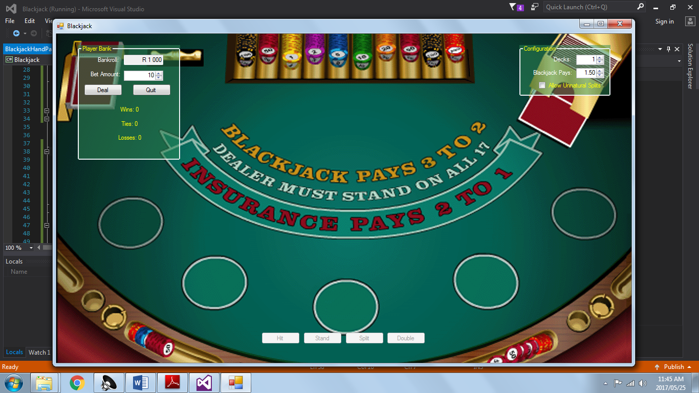

Deal:

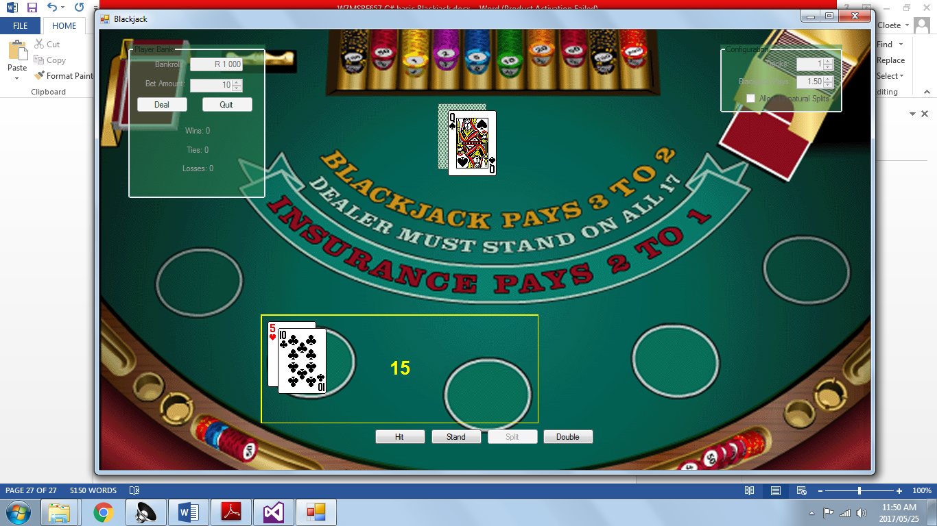

Bust and loss update:

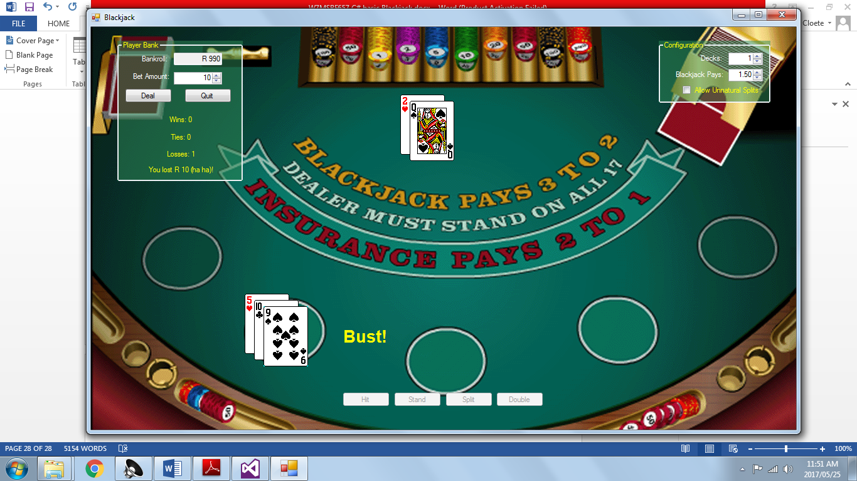

Dealer wins without player going bust:

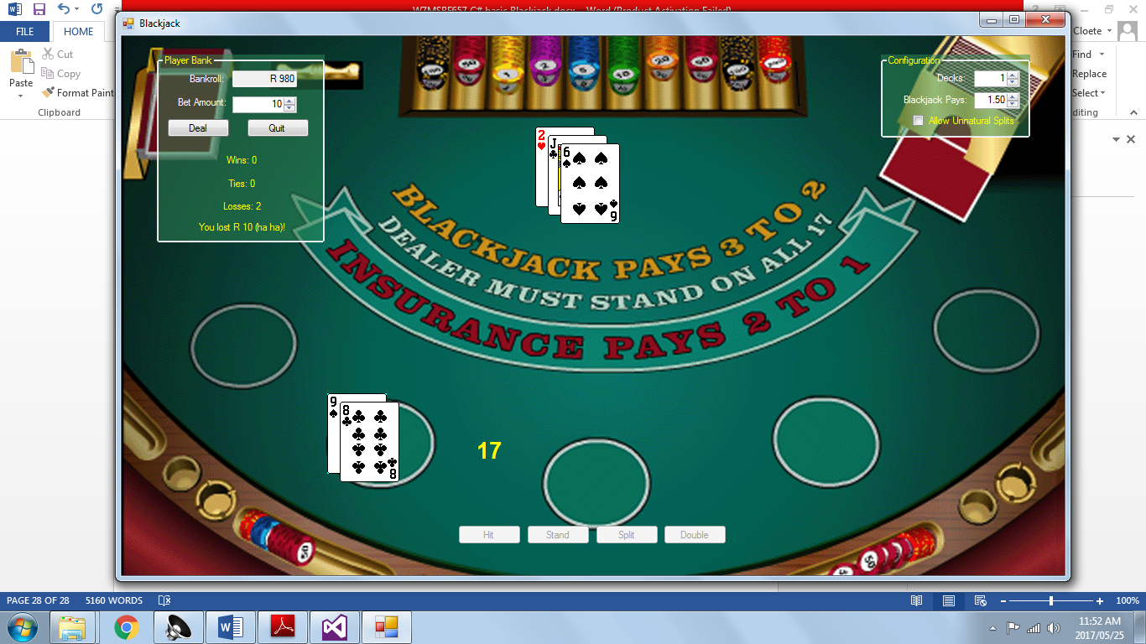

Player win, dealer bust:

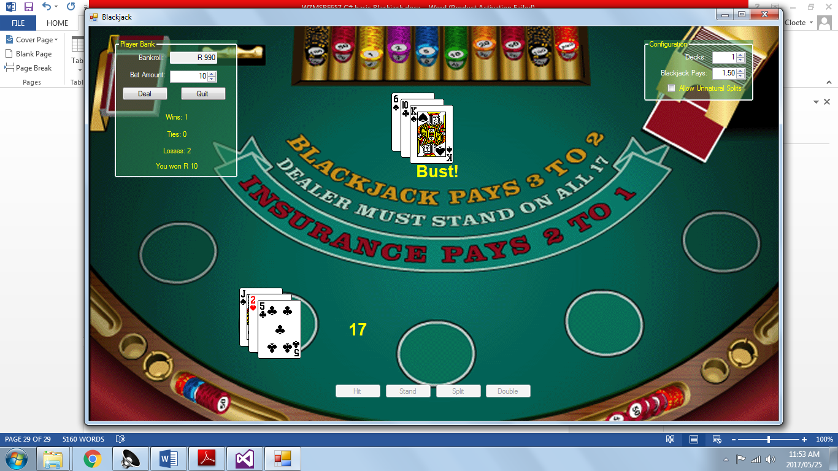

Player 2 card blackjack:

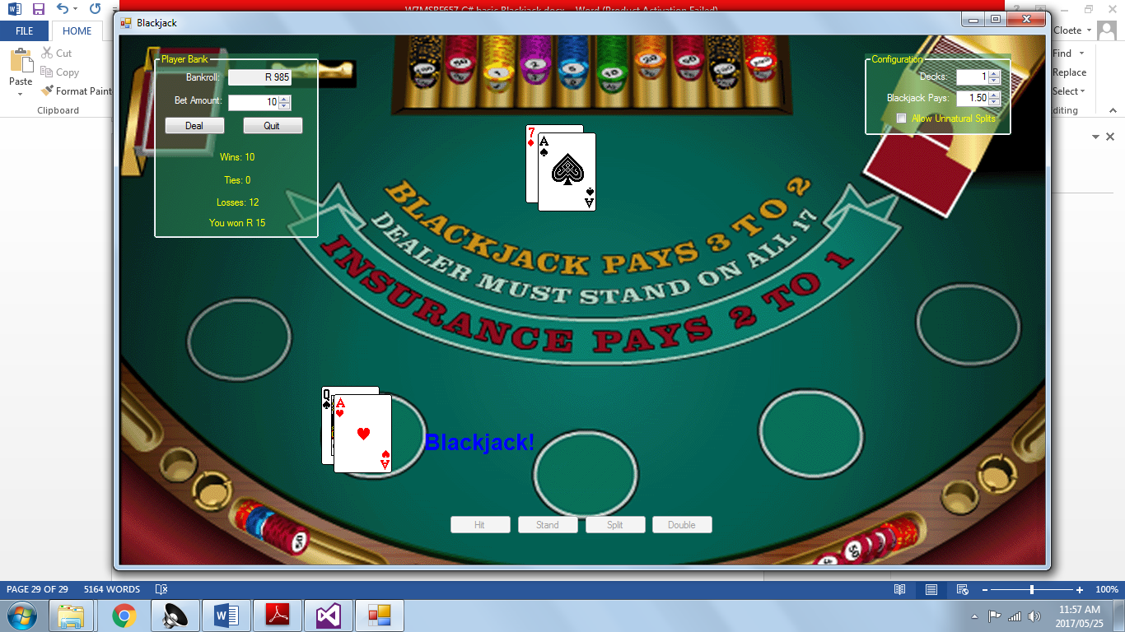

Player tie with dealer:

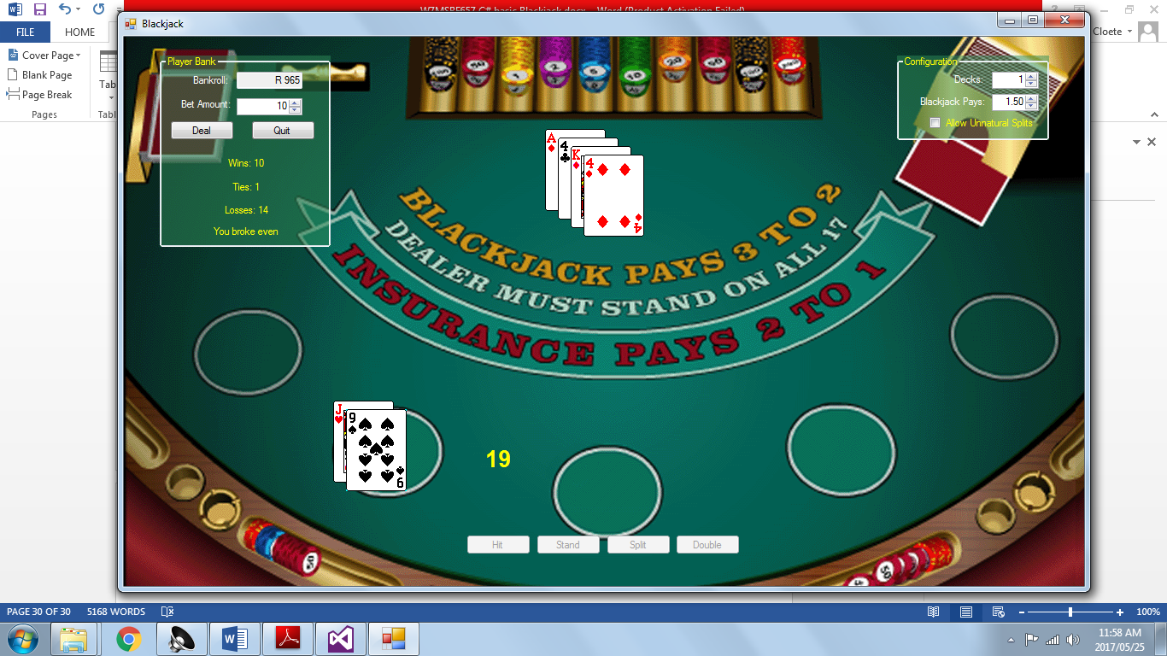

Dealt hand is splittable so button enables:

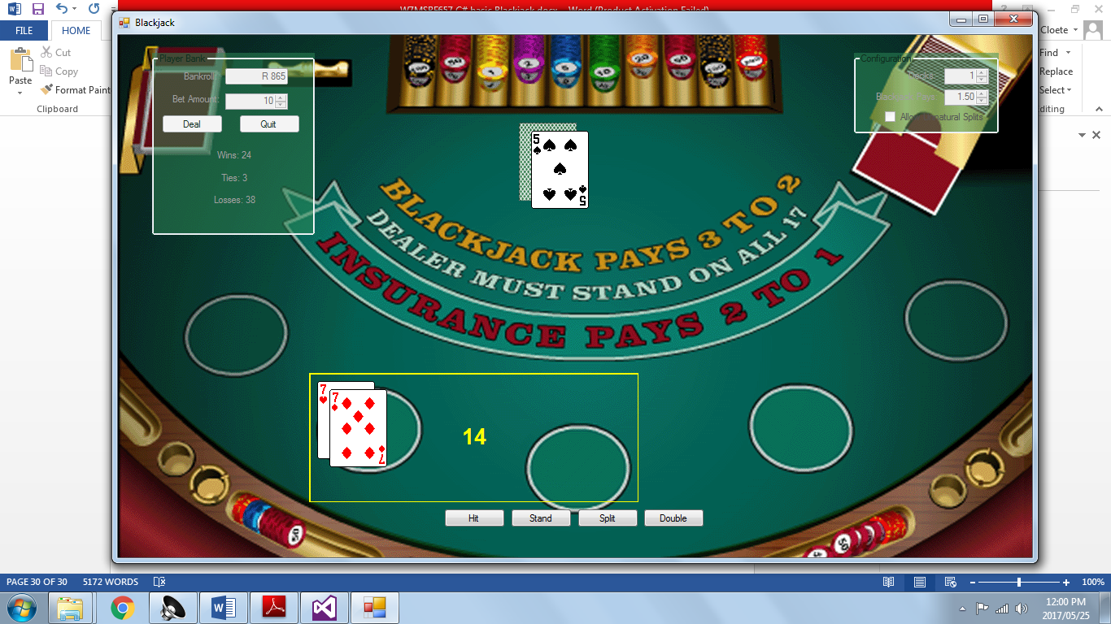

Result after hitting split: active hand is highlighted

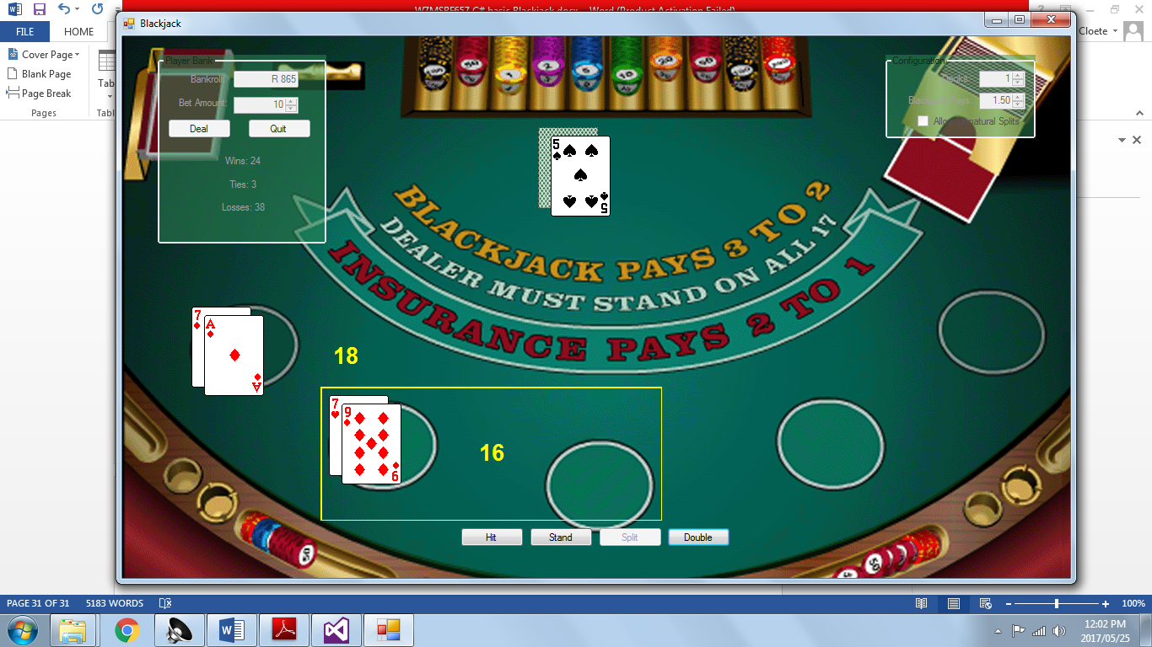

Active hand switch:

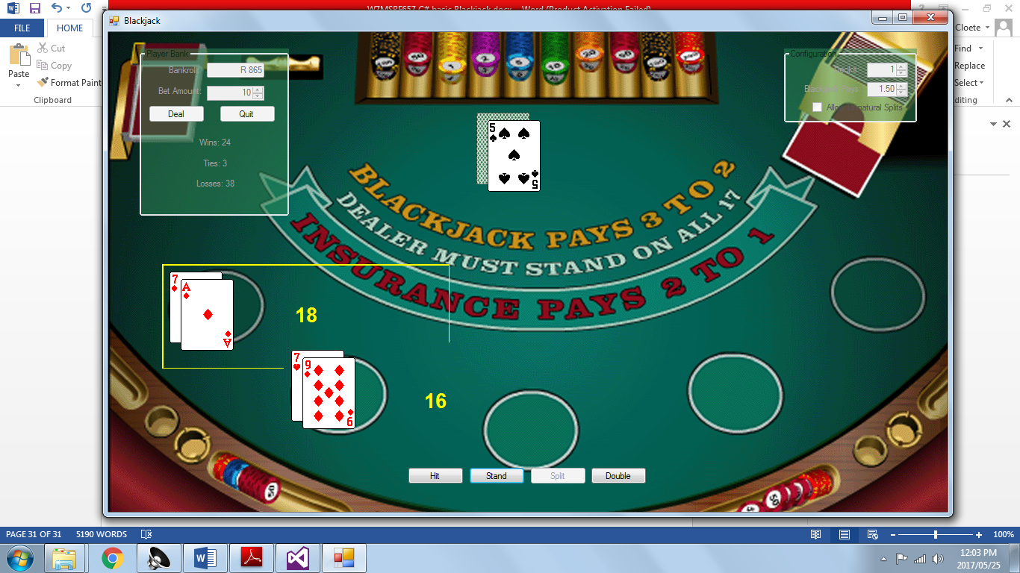

Result of winning split hand: only adds one win to scoreboard (win loss or tie is determined by the resulting change in the bankroll, money won is double the usual due to how the splitting mechanic works.

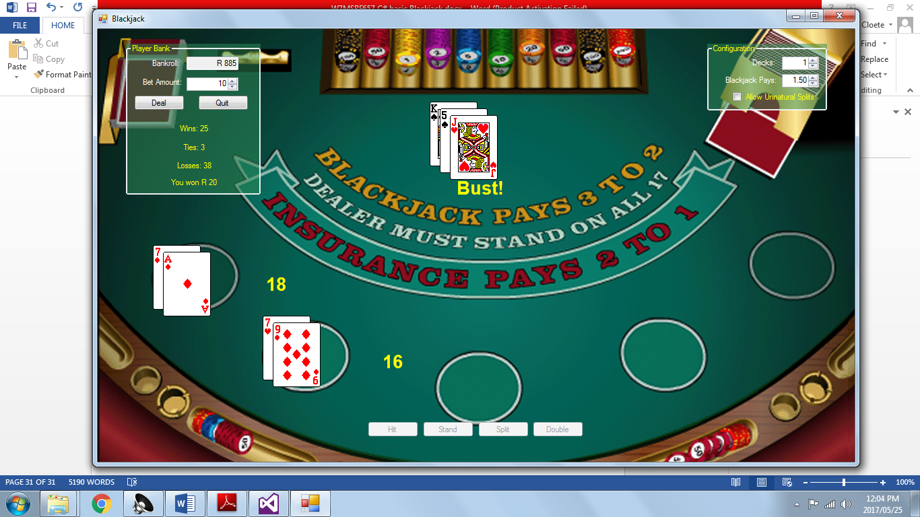

Using unnatural splits to show all hand spaces in use:

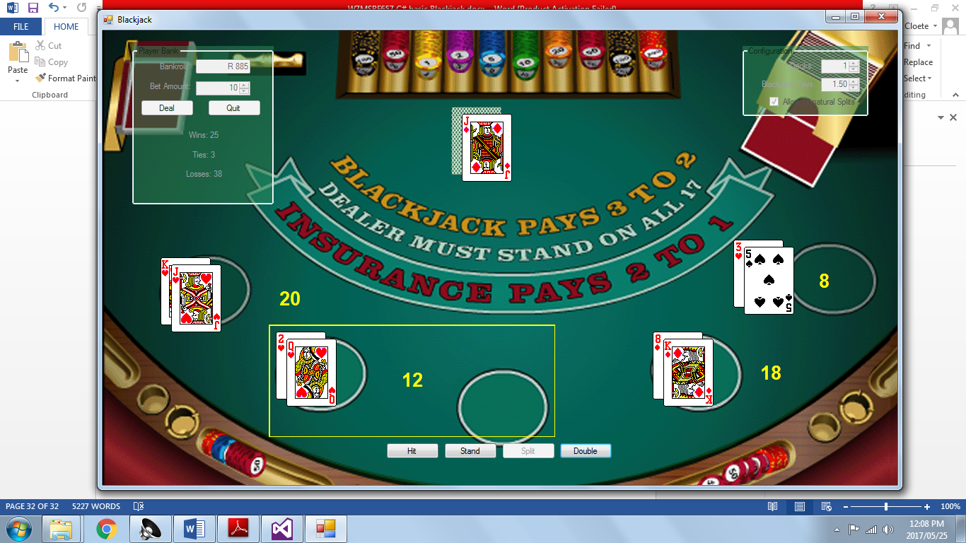

Tied result of 4 hand game: 2 hands won, 2 hands lost, dealer stood on 17.

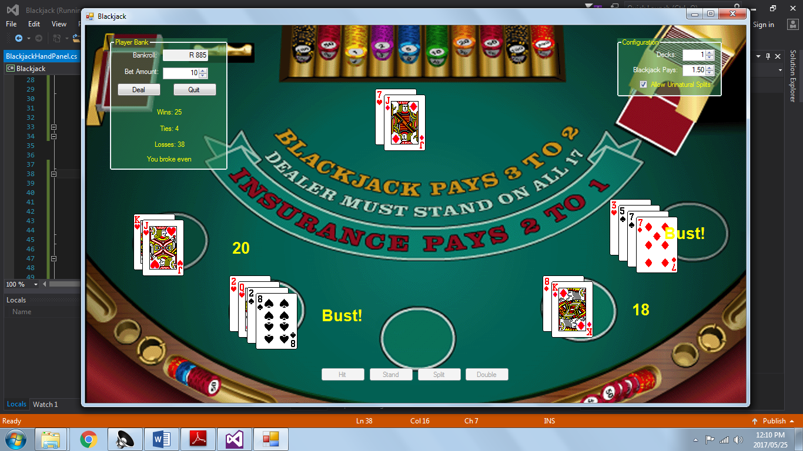

Result of double loss:

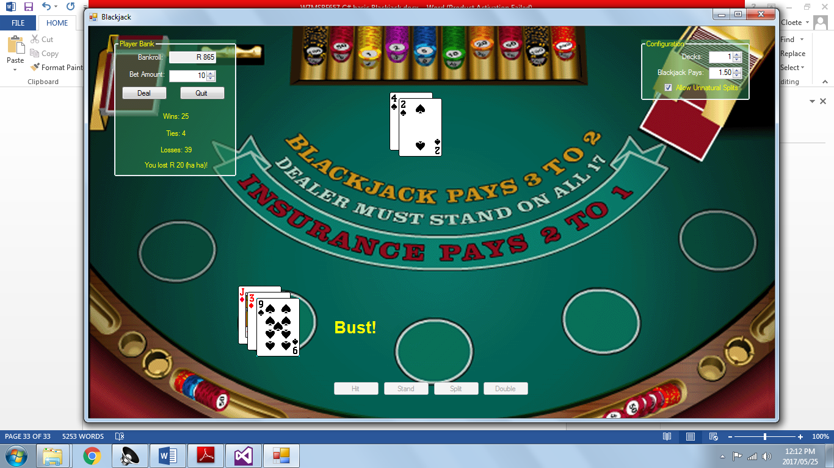

Player 2 card blackjack: gives increased pay-out based on ratio assigned in configuration box

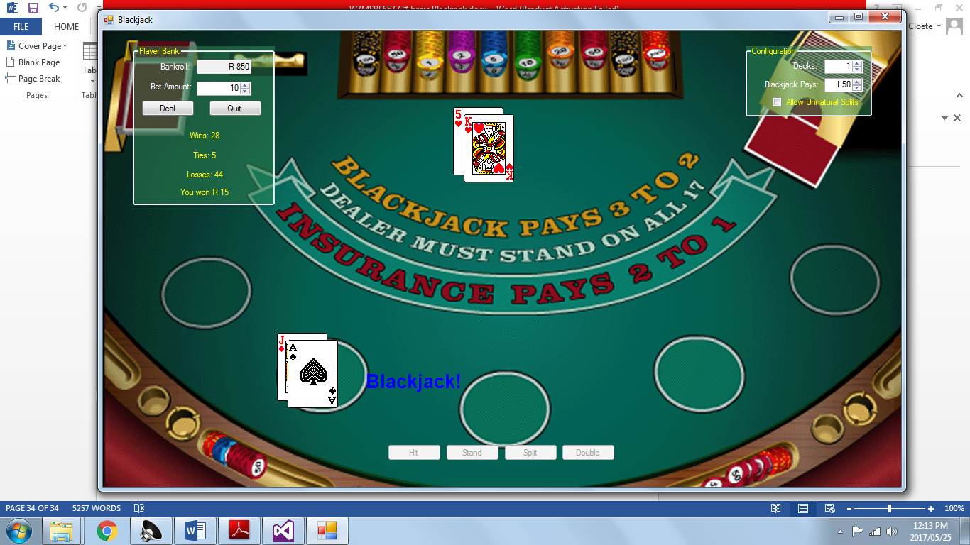

Increased pay-out for blackjack:

